Explainable LLMs with Visual analytics: a comprehensive review
Abstract
Artificial intelligence is becoming significantly important in the field of IT. With advancements in machine learning, particularly “deep learning,” AI has become very important. The technology and models used for AI are now so advanced that it’s difficult for humans to understand, even with the understanding of the underlying mathematics required to develop AI, the inner workings of the models are still unknown. The use of so-called ‘black box’ methods in modeling AI has made it uninterpretable, and thus untrustworthy. LLM is a field of deep learning that makes use of several transformer layers and other deep learning principles to perform several natural language tasks such as sentiment analysis, language translation, text generation, and text summarization. LLMs have got so good that they are now being integrated into several high-stake jobs such as finance, education and healthcare. With the tremendous advancement in these models, there is a need to understand the innerworkings and the logic behind its prediction before it is fully integrated into these high stakes’ situations. We are now being left with the question “Can AI be held accountable for its decisions? This is a big ethical concern. This has led to the emergence of a field called explainable AI (XAI), which aims to allow humans to understand what is going on behind the hood of these black box models. This paper aims to present a comprehensive overview of research in XAI, it offers detailed insight, analysis and summary of the current state of XAI research, pertaining specifically to LLMs.

INTRODUCTION
Artificial intelligence (AI) has been the most revolutionary technology of the last decade, according to reports by the International Data corporation (IDC) as of February 2025 the artificial intelligence Infrastructure spending is estimated to surpass the $200billion mark in the next 5 years. This shows that there is and will continue to be a growing demand for AI In the modern-day. Artificial intelligence is very much required in most of our day-to-day tasks, humans to an extent have become quite reliant on this technology, as it has made great leaps over the past few years, it is now being used in so many sectors where its output could have serious consequences. But if an AI makes a costly decision, who is held accountable? Many analysts accept the data generated by AI without knowing the rationale taken to get the outcome. The goal is to have AI also explain the Rationale taken to produce the outcome, so the Analyst can decide if the rationale is feasible. With the exponential growth of data, data has become a “resource” for industries to develop their business strategies and decision-making. The growth of data has also led to increasing demand in gaining insights on this data, Methodologies have been developed to help make sense of all these data, methodologies such as visualization, statistics-based data analysis, machine learning, data mining, and perceptual and cognitive sciences, it is still up for debate if any of these can adequately interpret the data in a form understandable to humans, In some cases, it can be argued that you need a combination of these subspecialties. One of the emerging ways data can be best understood is through visual analytics. Visual analytics is the science of analytical reasoning supported by Interactive Visual interfaces. Visualization provides a means of communicating the results of machine learning with humans.
Machine Learning is a subclass of AI that makes use of mathematical models to perform analytic or predictive tasks. Thes ML models are trained in specific data which have gone through the process of cleaning and preprocessing, so that accurate results are produced. There are various machine learning models tailored for performing various tasks, and while they mostly produce good results, we still do not know how and why they produce these results. While machine learning tools are still relevant today, more complex systems and algorithms have been developed, these systems are even more complex to understand due to their very high dimensions.
The breakthrough of large-scale language models such as ChatGPT and DeepSeek has stunned the world with their ability to respond to questions in a human-like manner, it has raised the question of how AI can be applied in all human endeavors. AI can now be involved in the process of Visualization, because of advancements in technology. Intelligent data visual analysis makes the process of visualization more efficient than the traditional methods used. There are two methods for explainable AI, the local and global explainability method. The local explainability method focuses on a single instance or prediction that the model makes, while Global explainability focuses on the functioning of the whole model. Dimension reduction and Visualization are three of the techniques used in global explainability, as they are intuitive and easily understood. Clustering is technique often applied for Local explainability; most surveys and papers mention the popular techniques of XAI but often neglect the preprocessing steps like Dimension reduction and clustering that make the visualization possible and meaningful, especially for complex LLM.

XAI Landscape
Due to the massive growth of the XAI field, there have been increasing number of scientific events and conferences. For instance the annual international conference series dedicated exclusively to the topic include fairness, Accountability and Transparency (FAT-ML) workshop at KDD 2014-2018 and ICML Workshop on human Interpretability in machine learning(WHI) 2016-2018(Adadi and Berrada, 2018). There are several high-level conferences, where the most brilliant minds in the field meet to discuss emerging topics in the field. Here is a list of a few XAI conferences that will be held soon:
- IEEE VIS 2026 :The premier forum for advances in visualization and visual analytics.
- Vis Meets AI: Focuses on AI-enhanced visualization (AI4VIS) and visualization-enhanced AI (VIS4AI).
- AI-Viz 2025/2026: International conference on AI and visualization, covering AI-driven workflows and interactive visual models.
- The Alan Turing Institute Workshop: Regularly hosts events on visualization for data science and AI.
- NVIDIA GTC: Covers AI, computer vision, and visualization techniques.
- Big Data Conference Europe: important topics in AI like ChatGPT, deep learning, and predictive analytics
- World Summit AI: on relevant topics like Generative AI, scaling startups with AI, and AI in finance and other industries
- The AI Summit London: wide range of topics, including how to use AI responsibly and its application in different industries
Several companies and organizations are investing a lot in XAI, in March of 2023, Elon Musk one of the wealthiest men in the world founded xAI, with the goal of creating a powerful AI-driven ecosystem that enhances human interaction on social media, while remaining transparent. Several companies have also got involved, The two leading players are ACM conference, and Defense Advanced Research Projects Agency (DARPA)(Minh et al., 2022). This is all shows the importance of XAI, it’s an emerging field with high growth potential, and has AI systems become more capable, the need for responsible AI increases.

Contributions
The existing surveys and literature reviews have done a good Job of breaking down fundamental concepts in the field of XAI and given the most up to date information for that period when the paper was published, but as said earlier XAI is a rapidly growing field with interest from a lot of large companies and research bodies, thus there is a need to regularly update the body of knowledge available. Compared to other reviews of the topic, this paper will go in-depth. This is done by reviewing the most relevant and up to date XAI articles and journals. Methods will be categorized on the level of explainability, and the inclusion of more complex models that were not spoken of in previous papers, such as research on attentionviz, visbert and other interesting XAI tools. A big concept most papers seem to lack is the evaluation of these XAI tools, there are certain procedures and tasks an XAI tool should be able to carry out to a standard before we consider them trustworthy. With the field still growing, there are many more challenges in the field of AI, and it’s explainability, this literature review will do a deep dive into that.

Background
XAI is a research field that aims to make AI systems more understandable, the term was first coined by Van Lent et al in 2004 (Adadi and Berrada, 2018). While the term is still new, researchers have had the problem of explainability since the mid-1970s (Adadi and Berrada, 2018). The focus of AI research in the last few years shifted from XAI to creating powerful models, but recently XAI is starting to receive traction in the research community. From Graph 1 we see an increase in the number of searches for XAI. The rise of powerful LLMs in the last few years has been a big reason for this. Due to years of focusing on more powerful AI algorithms and models, we now need the field of XAI to catch up with the abilities of these models. Models like Claude, Gemini, LLAMA, ChatGPT, DeepSeek etc. is now capable of performing tasks to expert human levels.
Explainability and interpretability are used interchangeably. Interpretability is the ability to explain or provide the meaning of something in terms understandable to humans; the definition assumes implicitly that an explanation is self-contained and does not need further explanations(Andrienko, N. et al., 2022). As with machine learning models themselves, there is no universally best XAI approach; the optimal technique depends on factors such as the nature of the data, the specific application, and the characteristics of the underlying AI model(Saarela and Podgorelec, 2024).

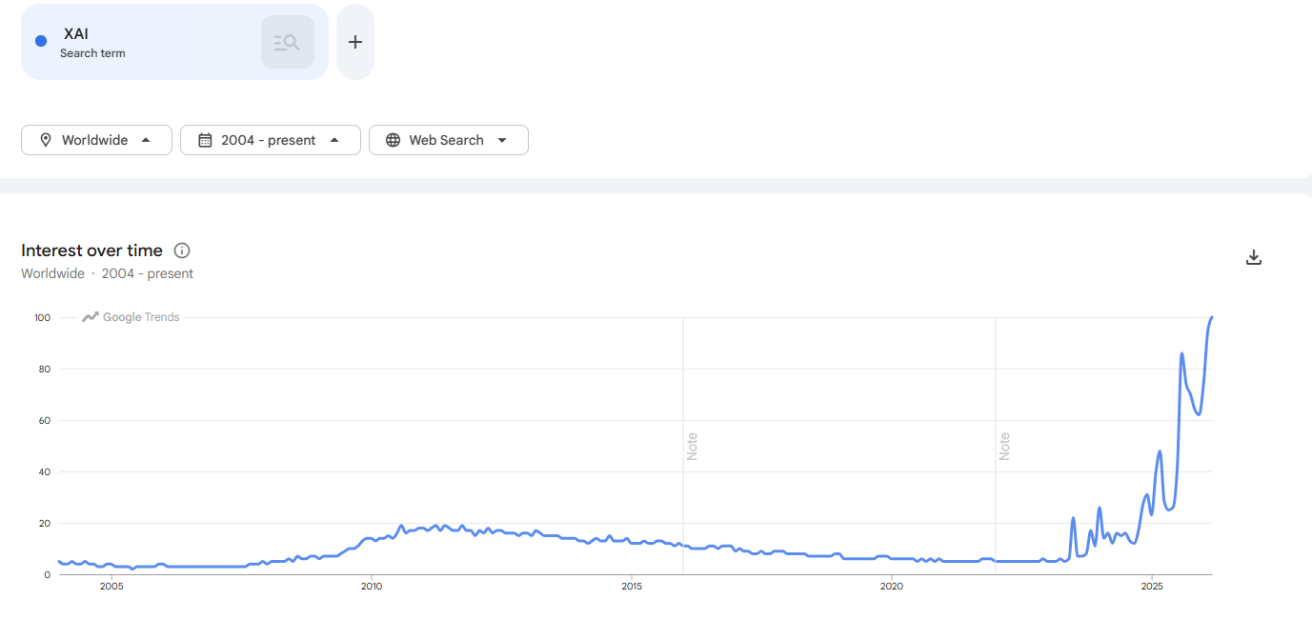
Graph 1: showing google trends search of the word XAI since 2004-2025

XAI term tends to refer to the movement, initiatives, and efforts made in response to AI transparency and trust concerns, more than to a formal technical concept. According to DARPA, a leading body in XAI research, XAI aims to ‘‘produce more explainable models, while maintaining a high level of learning performance (prediction accuracy); and enable human users to understand, appropriately, trust, and effectively manage the emerging generation of artificially intelligent partners’’(Adadi and Berrada, 2018). The goal of XAI is to ensure that the decision of AI models can be explained to end-users and other stakeholders in non-technical terms. The primary goal of this review is to investigate the recent applications of XAI with visual analytics across various domains. There are several ways explainable AI can be categorized, and this image does a good job of highlighting them. XAI can be categorized on various metrics some of them are stage of explainability, Scope of explainability, Applicability, explanation mechanism.

What are Visual Analytics?
VA is the science of analytical reasoning supported by interactive visual interfaces(La Rosa et al., 2023). VA combines computer driven and human interactive components, to create understanding of complex models. With human input, we can steer VA systems to generate new visualizations and analyze data from a different perspective, which can lead to a better ability to investigate problems. Jeroen Ooge et al (2021) details several ways in which visual analytics can be interacted with, these are Abstract/elaborate, connect, Encode, Filter, Reconfigure, and select (Ooge et al., 2022). Very often the challenge with applying AI and analytics in real-life scenarios is the level of complexity and information that is derived from the interfaces. In most cases, it would be wise to tailor the amount of interactivity involved during the visual analytics process so end users can be involved in the design process and easily identify their needs. This is known as human in the loop and builds trust for the system used. The interpretation from Most XAI models are mathematical representations, these are less intuitive for human understanding, presenting the findings as interactive visualizations, is the most intuitive way to get humans to understand the inner workings of these complex models. Fig 3 shows the visualization process. Visualization methods and techniques depends on the kind of represented data, such as text, numbers, multidimensional or hierarchical data, or networks (La Rosa et al., 2023).
What is XAI?
Explainable Artificial Intelligence(XAI) is a new research field that aims to provide understandable artificial intelligence(AI) results for end-users(Alicioglu and Sun, 2022). Most machine learning, and deep learning models are “black box”, this simply means the inner workings of these models are unknown, the goal of XAI is the make these models white box, thereby providing understandable, trustworthy, and explainable rationales for decisions made by the black box models. While some studies mathematically define explainability, other studies emphasize that explainability should include more non-technical concepts to increase human-understandability(Alicioglu and Sun, 2022). The XAI methods can be divided into three main categories based on explanation level, implementation level, and model dependency. The subcategories of the explanation level of an XAI method are named global level, which focuses on the explainability of the entire model, and its working and decision-making mechanisms, and local level, which explains the decisions of a model for a single instance or subpopulation.
A very important aspect of this research and the progression of Visual analytics in the explainability of AI is its ability to take human input and interaction. Fig 2 shows how XAI opens a black box making it more explainable. XAI can also be categorized based on the stage that the method is applied, the stages are pre-modelling (EDA), Interpretable model (intrinsic model), post-modelling (post-hoc explainability). The final categorization of XAI is on the restriction of use of a method, some methods are restricted to a particular model, they are model specific. While others can be used for several models, they are model agnostic.

XAI with LLM
The rate at with AI technology has developed rapidly in the last few years, to the extent where it has begun to surpass human abilities in certain tasks. But as predictions have got more accurate, interpretability has been sacrificed, we have seen a steady tradeoff in our ability to understand these complex models as they get better, thus leading to a “black box” effect. XAI is a movement that aims to make the complex large language models more explainable. Several techniques have been proposed to make LLMs explainable, some of the techniques are attribution, Interpreting model internals, explanation of latent representations, and sample-based explanations. Researchers in the field have made use of several of these methods, sometimes in combination to explain LLMs and their predictions, in the next section we’ll be discussing some popular tools that make use of these techniques.

Explainable LLM with visual analytics: the current tools and methods in the landscape
Several tools have been developed to cover the gap between the growing accuracy of LLMs and the lack of explainability, many efforts have been made by XAI researchers, producing tools using various techniques to demystify these black box models. Jesse Vig in 2019 proposed BERTVIZ, a tool designed to tackle the challenge of multiple attention heads by introducing a high-level model view, which visualizes all the layers and attention heads in a single interface, and a low-level neuron view, which shows how individual neurons interact to produce attention (Vig, 2019). The tool comprises three views: attention-head view; Visualizes the attention patterns produced by one or more attention heads in each layer; attention is represented as lines connecting the tokens that are attending with the tokens being attended to.
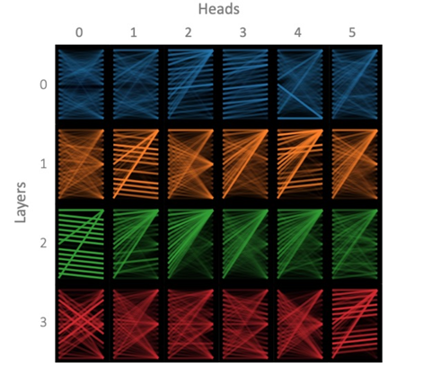
model view; The model view provides birds eye view of attention across all the model’s layers and heads for a particular input. Attention heads are represented in tabular form with rows representing layers and columns representing heads(Vig, 2019).
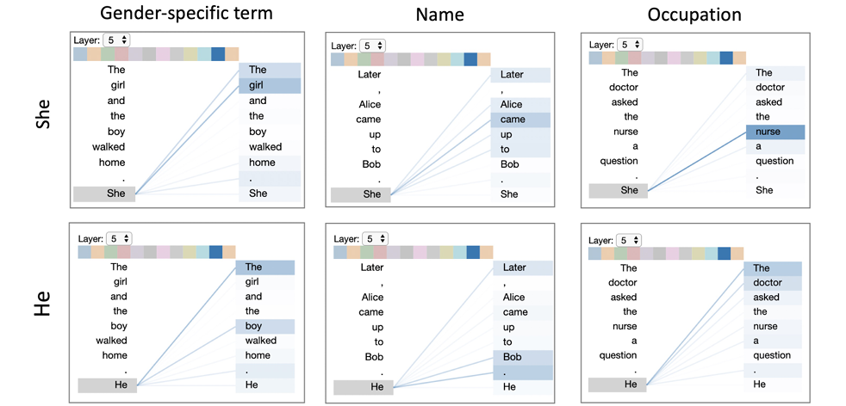
Finally, the neuron view; The neuron view visualizes the individual neurons in the query and key vectors and shows how they interact to produce attention. These views are used for the GPT-2 and BERT models, and they were applied in three use cases detecting model bias, locating relevant attention heads, and linking neurons to model behavior (Vig, 2019)
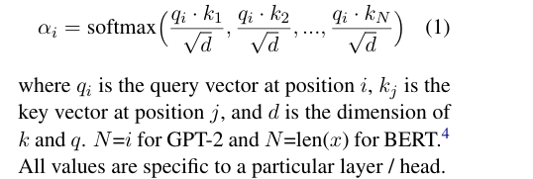
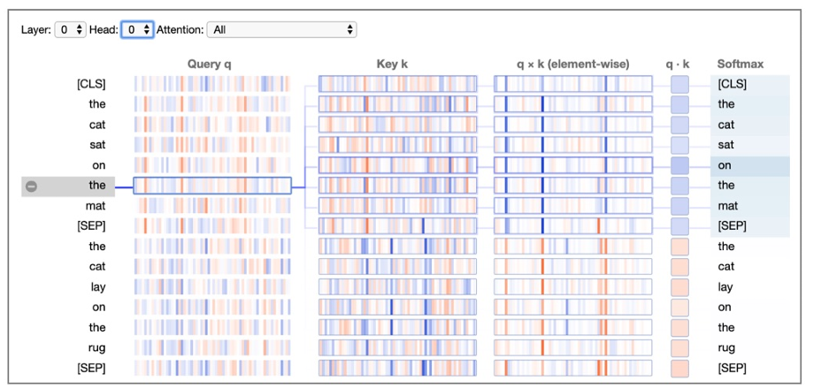

Over the years, attention alone has been debunked to not be a standalone reliable source for explaining transformers predictions leading to other methods being used alongside attention visualization. Many of the tools being developed today make use of Jesse Vig visualization for the presentation of attention, especially the model level as it gives a depiction of sentence level attention. Among the users of Jesse’s model level view for sentence attention understanding is Catherine Yeh et al. Catherine Yeh et al. in 2024 proposed AttentionViz, a tool to understand the self-attention mechanism of transformers; self-attention is the most revolutionary discovery in transformers; hence a lot of researchers direct their resources to understand how it influences the LLMs prediction. Although self-attention has been studied, previous techniques generally visualize information related to just a single input sequence at a time. Previous research produces bipartite graphs or heatmaps representations of attention weights for one given input sequence(Yeh et al., 2023). The primary technique of this research is visualizing a joint embedding of the query and key vectors used by transformers, which then creates a visual signature for an individual attention head.
AttentionViz is an interactive visualization tool that allows users to explore multiple levels of detail, with options to view attention heads globally in the global view, view a single head in the single view, or go down to the sentence level and view the self-attention relationships shown in FIG . A major contribution of this research is visualizing the key and query embeddings in low dimensional manifold using dimensionality reduction. This tool goes beyond language transformers and is also used for vision transformers, however due to the scope of this paper we will only touch on it’s use for language transformers. A key observation is that the relative positions of query and key vectors can offer insight of how attention will be distributed, since attention coefficients depend on the dot product between queries and keys. Closer distance directly shows higher attention coefficients.
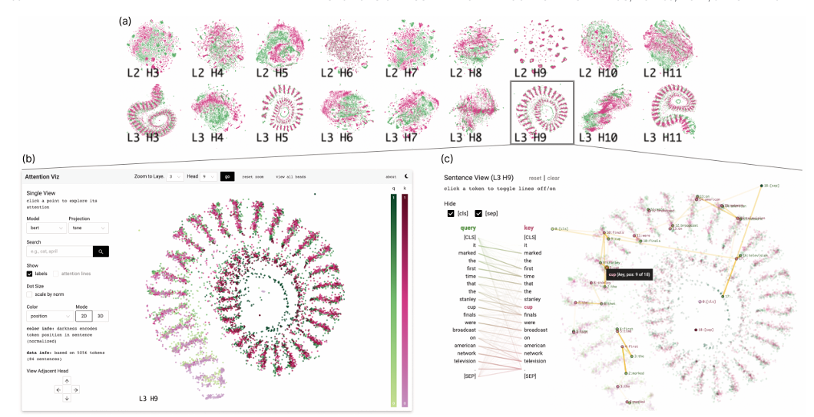
FIG

Another tool that makes use of dimensionality reduction techniques is VisBERT, Proposed by Betty Van Aken et al. in 2020, this tool was deemed necessary because prior research has shown attention cannot be solely relied on for explainability. Thus, this research presents a complimentary approach that might aid explainability. This experiment visualizes the hidden state between BERT layer and the token representations as they are transformed through the network(Aken et al., 2020). Popular publicly available QA datasets SQUAD, HotpotQA and bAbi QA were used to show the tools applicability on three diverse QA tasks. Each layer of BERT outputs a different token distribution; to understand the semantic relationship between token vectors, we consider the distance between token vectors. Dimensionality reduction and k-means clustering were the method used. The advantages of PCA to other dimensionality reduction techniques are its ability to maintain the local structure and the speed of its response. PCA is also suitable with k-means clustering as it reveals clusters that correspond to those of k-means clustering. The tokens are color coded into Question, supporting fact, context and predicted answer. After coding the tokens. They are then projected into 2D manifold, this way the distance between tokens can easily be analyzed.
Visbert has 4 phases, these phases are Topical clustering Phase; In the first layer tokens are clustered based on topical similarities, comparable to a static word embedding like Word2Vec. Connecting Entities with Mentions and Attributes Phase; Middle layers tend to cluster tokens based on their specific context. For instance, multi-token entities are clustered together because their tokens share one semantic meaning. Matching Questions with supporting Facts Phase; In the third quarter of BERT layers, we see question tokens, form clusters with supporting fact tokens. Answer Extraction Phase; In the last layer, the answer tokens are separated from all other tokens. FIG shows VisBERT in Answer Extraction Phase
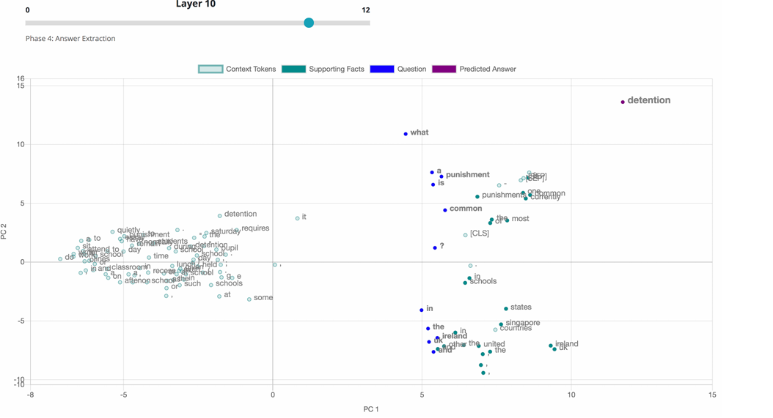
FIG

Ben Hoover et al. proposed a visual analysis tool in 2020 called EXBERT which focuses on adding to the limited body of knowledge that goes beyond attention. This research focuses on moving beyond static attention visualization toward representation-centric analysis, which centers on linguistic and semantic information encoded in the layers, where it emerges, and how it changes across each layer and tasks. The model project is viable for different transformers; it was used for both masked and autoregressive transformers. The contribution of this research is contextual token representations, nearest-neighbor relationships in embedding space, layer-wise representation evolution, and cross-model comparison (Hoover et al., 2020). EXBERT’s interface has two views which allow for token and layer understanding, these views are the attention view; here we can see the tokens arranged in two parallel columns with attention A flowing between them, from the query tokens to the value tokens, hovering over a token will spotlight the token so we see incoming and outgoing attention of that token, this view is shown in FIG. And the corpus view; this view allows for similarity search of the annotated corpus, results with the highest matches are shown first, and presented visually by a histogram to show the features of the matched representations, from the most similar with the highest count. This view is shown in FIG


Similarity search is made possible by EXBERT using tokenizing, normalizing, and labeling sentences with spaCy, this gives linguistic features to the tokens which can then be used in the histogram. With this tool Layer-wise analysis is possible; these analyses align with consensus that lower layers encode surface and syntactic information, middle layers encode semantic relations, and higher layers encode task- and objective-specific abstractions. This research is limited in its scalability, faithfulness, and expert’s bias insights pertaining to their linguistic insights(Hoover et al., 2020).

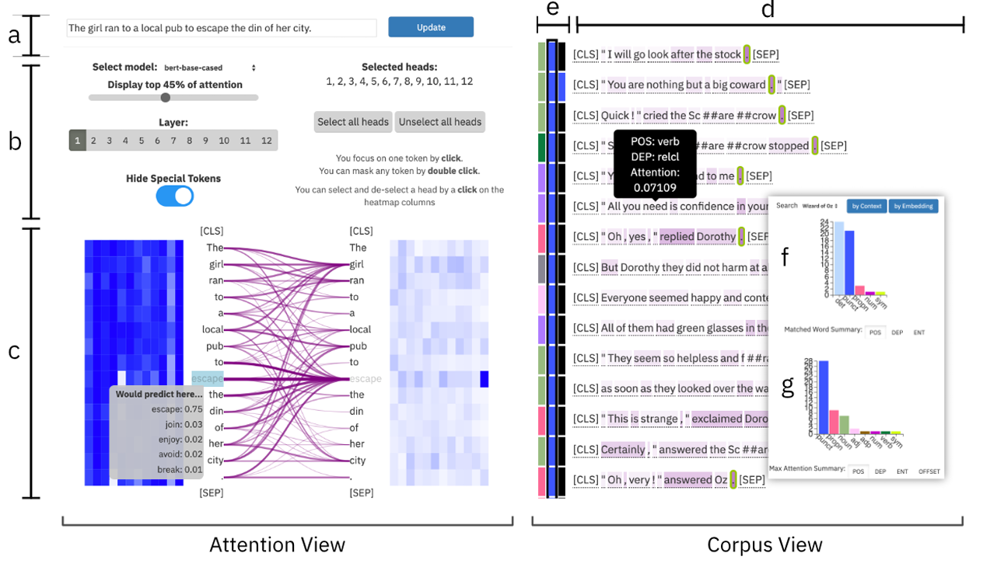
FIG

Ben Hoover et al. are not the only ones now focusing on semantic and syntactic meanings of tokens, other researchers in Georgia tech were also focused on their own research which focuses on these same issues, but with a different presentation. While Ben hoover focused on finding nearest similarities in the embedding space the identify the masked or next predicted token, Wang, Z. J. et al focused on identifying attention heads inclination, either syntactic or semantic. Wang, Z. J. et al. researchers from Georgia tech in 2021 proposed a tool for exploring transformer models called DODRIO, which integrates an overview that summarizes the roles of different attention heads. Existing visualization does not connect attention mechanisms to linguistic knowledge, here is where DODRIO comes in to fill this gap. DODRIO has various views that aid explainability, the views are Attention head overview; This views allows for effective exploration of the remaining views, with a grid view of attention heads that guides the user to inspect semantically and syntactically important heads, the former encoded as circles where the deeper the red the more semantic the head, and the latter as blue, where the more syntactic head is a deeper shade of blue and the size of this circle represents it’s importance scores. The Syntactic dependency view shows word relations in a sentence are important features to understand the sentence. The relations in this view are tagged by CoreNLP pipeline linked with the semantic attention Graph. Semantic attention Graph view is primarily used to inspect semantically significant attention heads, this view is customizable with interaction to allow for detailed attention inspection, with a grid layout and radial layout. Instance selection view allows users to explore the behavior of attention across several different sentences, and provides the Embedding view, which uses the dimensionality reduction technique UMAP to project text instance’s to 2D space and visualize it as scatter plot. Then we have the last view, the table view which allows for instance selection while providing users with instance’s true and predicted labels. Figure 8 provides an image of the main views in Dodrio. The initial experiment was performed on BERT, but the researchers also performed this experiment on a smaller model of BERT called DistilBERT to observe how its behavior would vary from the BERT model. They noticed all the radial attention heads have the same diameter, unlike BERT and there was a similar pattern of syntactic and semantic attention heads, however later layers have higher brightness, showing this head neither attended primarily to text semantics or grammatical structure. The limitations of this research are the scalability, especially in portions that pertain to syntax tagging, faithfulness of the model, limitation to masking model and expert bias due to linguistic understanding. This model does a good job of creating beautiful visuals but is not intuitive even for more advanced users in the field.
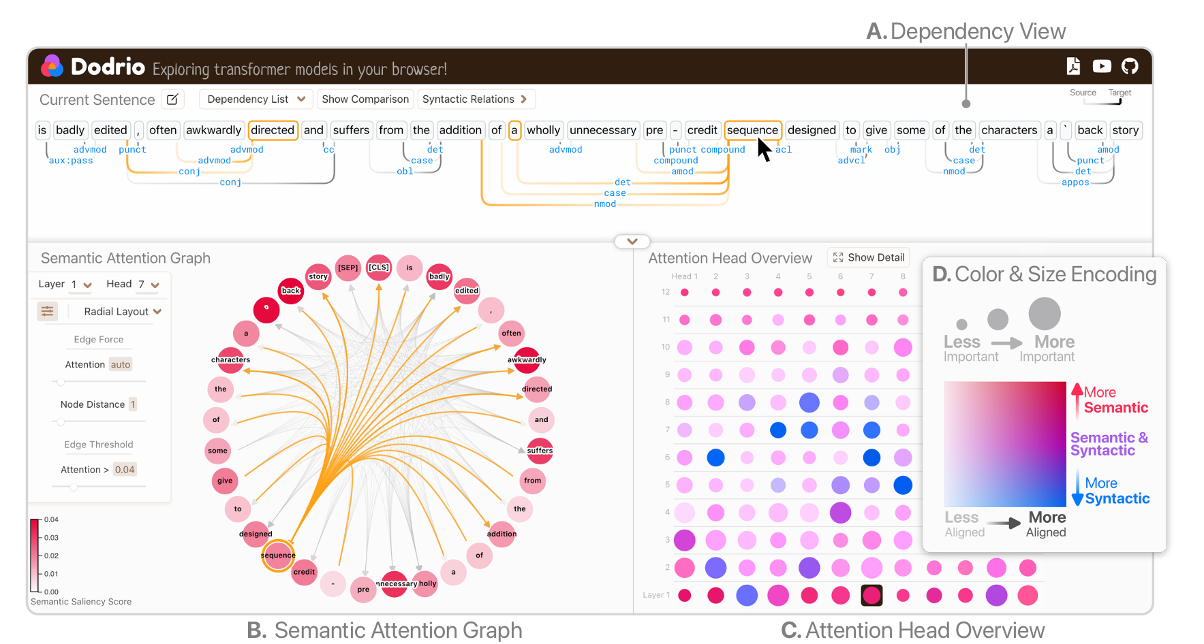
(Lal et al., 2021) proposed a novel method for explainability called InterpreT, which contributed to the research field a single system that enables users to track hidden representations of tokens, just like VisBERT, through each layer of the transformer, but can also be used to visualize and analyze attention head behaviors like BERTVIZ. The dimensionality technique used in this project is t-SNE, this preprocesses the extracted hidden representations. A key feature of this tool is the tracking of visualization plots of t-SNE representation of hidden states through layers of the transformer. InterpreT has several views to understand transformer prediction, the views are head summary, which displays attention head summary statistics for each head and layer. Attention matrix map View Task provides the ability to display the attention patterns and weights exhibited by specific attention heads, which can be selected by clicking on a specific head and layer in the head summary plot Interpret, this attention patterns can be displayed as heatmaps or token maps. T-SNE Embeddings view allows for tracking of t-SNE representations of hidden states through the layers of a Transformer. The last view is the Average t-SNE distance per layer, this view was put to complement t-SNE visualization of the hidden states, this novel plot shows the average t-SNE space distance between specific groups of terms across all the Transformers’ layers.
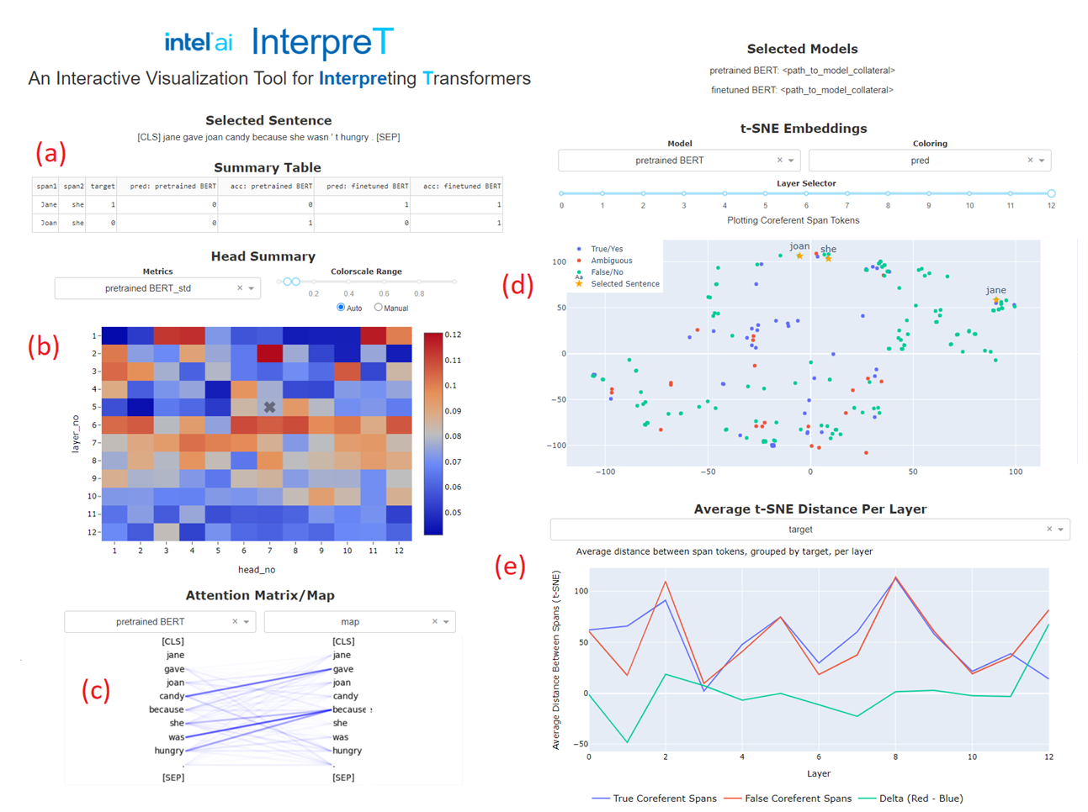

This tool was used with the base BERT model and a linguistically informed BERT (LIBERT), both were finetuned on laptop reviews and then evaluated on restaurant reviews. LIBERT received an aspect extraction F1 score of 0.5143 and BERT a score of 0.4254. This shows that the tool can detect the improvement the LIBERT model gains from the added syntactic 13th layer. This is a very interesting tool; however, the visualizations appear very static and there is low interactivity compared to visualizations discussed earlier.
Very few tools available allow for token/ sentence level exploration and explainability, and give in sight to how the LLM makes sense of the sentence as it goes through the layers, EXBERT does this, however Yun et al., in 2021 research focused on this as the primary method of explanation, they developed a tool called TransformerVis. This paper proposes dictionary learning techniques to open this black box as linear superpositions of transformer factors. “Probing task” technique used to interpret transformers by attaching light weight auxiliary classifier trained on well-known NLP tasks is limited, thus the introduction of dictionary learning to solve the limitations. The paper hypothesizes that contextualized word embedding as a sparse linear superposition of transformer factors. It proves that word embedding vectors can be factorized into sparse linear combination of word factors.
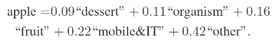
We collect a contextualized embedding of every word using a transformer model. We define the set of all word embeddings across all layers into a single set
X = X¹ U X² U ……U X^{L}
By the hypothesis, embedding vector x ∈ X is a sparse linear superposition of transformer factor

Where $Φ∝+R^{dxm}$ is a dictionary matrix with columns $Ф_{:,c}$, $∝∈ R^{m}$ is a sparse vector of coefficients to be inferred and ∈ is a vector containing independent Gaussian noise samples, which are assumed to be small relative to x. Typically m > d so that the representation is overcomplete.
Since we cannot visualize hidden dimensions of transformers to obtain semantic meanings when top activation is triggered, the researchers try to visualize the transformer factor $Ф_{:,c}$ and for a layer-l, we denote 1000 contextualized word vectors with the largest sparse coefficient $α_{c}(l)$ as $X_{c}(l)$ ⊂ $X(l)$, which corresponds to 1000 different sequences. Since a contextualized word vector is generally affected by many tokens in the sequence, we can use LIME to assign a weight to each token in the sequence to identify their relative importance to $α_{c}$. To determine low-, mid-, and high-level transformer factors with importance score, we build a single dictionary for all layers, A major question in representation learning is “Where does the network learn certain information?” To answer this question, we compute an importance score for each transformer factor as I_{c} . where I_{c} is the average of the largest 1000 sparse coefficients α_{c}, which corresponds to $X_{c}$. We plot the importance score each transformer factor as a curve
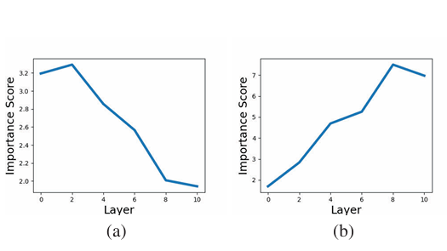
An experiment was performed with a pre-trained BERT model, to show that the transformer factors correspond to different levels of semantic or syntactic patterns. At layer 0-4, Low-level, we notice transformer factors with early IS curve peaks usually correspond to a specific word-level meaning, we also see word level disambiguation gradually develop in the transformer when the top activation sequences are visualized. This is shown in FIG
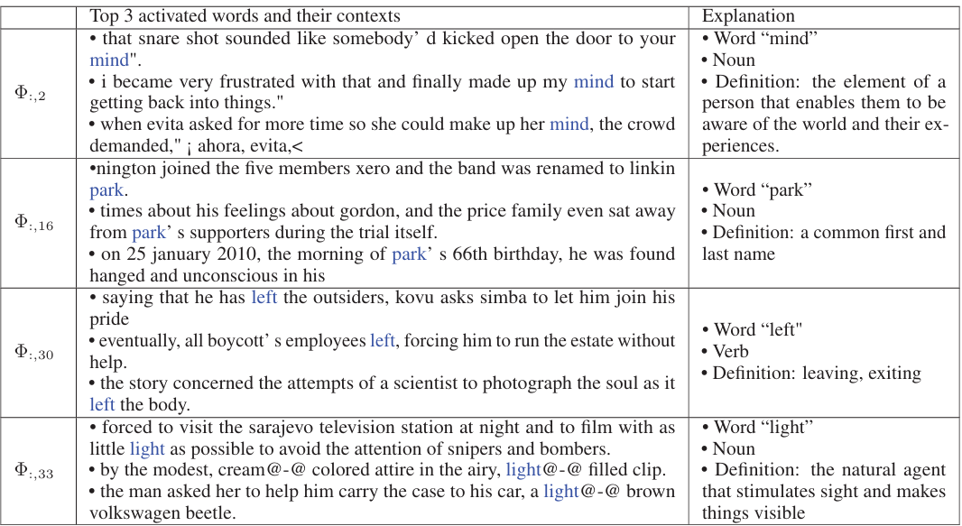
FIG
We notice that “left” is being used as a verb in the word sense of exiting or leaving, we can then agree that when “left” is used as a verb it triggers higher activation in $Ф_{:,30}$, than “left” used as other sense of speech. This hypothesis is further verified by using Brown corpus (Francis and Kucera, 1979). The researcher collected all the sentences that contains the word “left” annotated as a verb in one set and sentences contains “left” annotated as other part-of-speech. in layer 0, the average activation of :30 for the word “left” marked as a verb is no different from “left” as other senses. However, at layer 2, “left” marked as a verb triggers a higher activation of $Ф_{:,30}$, In layer 4, this difference further increases, indicating disambiguation develops progressively across layers. Shown in FIG
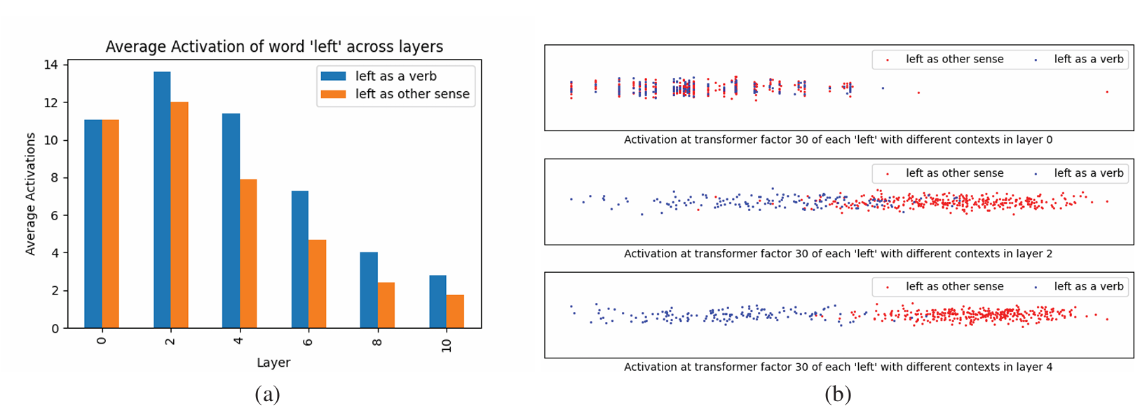
FIG
Yun et al., found that most of the transformer factors with an IS curve peak after layer 6 show mid-level or high-level semantic meanings. Midlevel corresponds to semantic patterns like phrases and sentences pattern. The experiment had an instance where adjectives, unit exchange and sub-structures were being detected, the patterns tend to emerge at layer 4, develop at layer 6 and become prominent at layer 8. FIG below shows the mid-level transformer factor, and the patterns they detect, the percentage of top 200 activated words at different layers
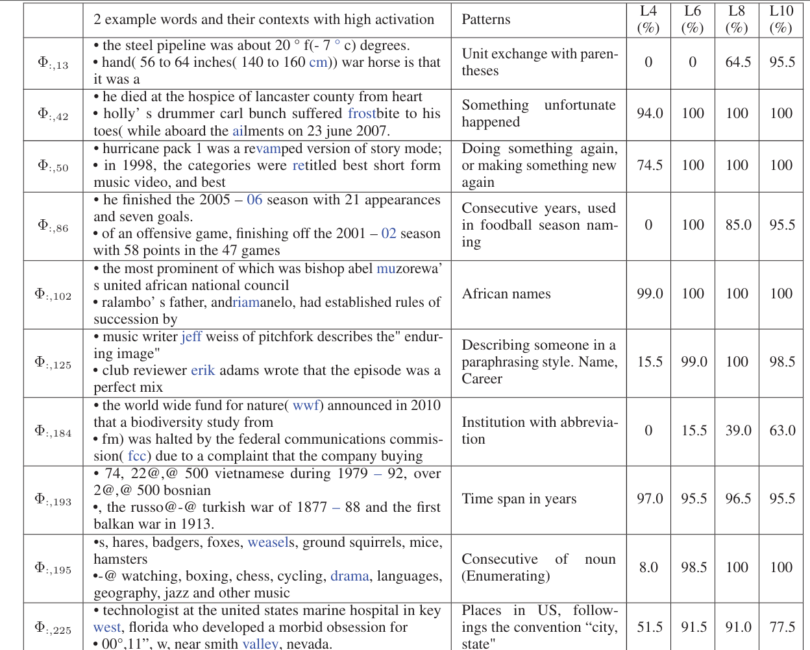
FIG
The last level of transformer factor is the high level, and it corresponds to linguistic patterns that span an extended range in the text. The IS curve of mid-level and high-level transformer factors are similar, so it’s difficult to distinguish them based on this. Yun et al instead used the manual examination of the top-activation words and context for each transformer factor for differentiating these two levels. The paper makes use of LIME to identify the contribution of each token in the sequence. The color reflects the weights w at each position. Red means the given position has positive weight and green means negative weight. The magnitude of weight is represented by intensity. The redder a token is, the more it contributes to the activation of the transformer factor.
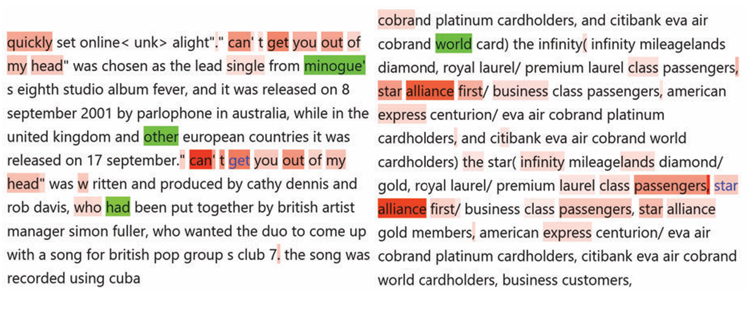
FIG
FIG shows a “repetitive pattern detector”, for transformer factor $Ф_{:,297}$. All the top activated contexts for this transformer factor contain repetitive structure. the high-level patterns like “repetitive pattern detector” are much more abstract. The transformer detects if there are two (or multiple) almost identical embedding vectors at layer-10 without caring what they are. Of all the tools we’ve reviewed this is the least intuitive, though it presents the corpus untransformed, it is less intuitive than other tools that transform the corpus into beautiful visualizations, this is also why it’s the tool with the lengthiest explanation. An advantage of this model is that it can be applied to other models that make use of skip connections, like VIT, and ResNET.
All the tools above have their benefits; however, some tools succeed in performing certain requirements for explainability than others. Of all the tools that make use of dimensionality reduction technique, VisBERT is the easiest to understand, specifically because it was applied to a question and answer use case so the understanding we gain is a real life scenario of an LLM predicting the accurate answer to a question, and those we can follow the layers to better understand how it comes to this conclusion, VisBERT makes use of PCA which shows the priority is to preserve the local structure, the use of K means clustering further proves the importance for local structure preservation, visBERT is however not as effective for application with autoregressive transformers, and struggles with multihop tasks visualization. AttentionVIZ provides amazing visualization, but it does not really explain the LLM in a way a user’s will benefit from, though it provides beautiful visualizations, it leaves it’s explanations very open to interpretation, this would not be the case if this tool was built on understanding tasks performed by LLMs in real world scenarios, the tool is positioned in a manner that show LLMs understanding of input, however it will be more beneficial for our understanding if it shows how it predicts it’s outcomes. attentionVIZ focus on attention makes it quite limited in its explanation, has several studies have now debunked that attention is not enough of an explanation. InterPreT also makes use of dimensionality reduction however it makes use of t-SNE. This shows that the global structure of the model is prioritized, the model is not limited to just attention or a wise understanding, it takes things a step further by providing an understanding of both. The tools interactivity however is very shallow and will benefit from a real-world use case scenario. Dodrio provides very beautiful visualizations, explaining both syntactic and semantic understanding of transformer attention, we are able to identify how and what head specializes in what lexical task, however it has the same issue attentionVIZ has, the tools are built to understand attention, and this is not enough explanation of why an LLM makes the decision it does.
Ben Hoover et al’s research tool ExBERT was particularly interesting. It combined explanation of attention with similarity search, compared to the models listed above this gives insight to how predictions and unmasking can be done by LLMs. Tagging word with part of speech makes similarity search possible, the part of speech with the highest count is most likely to be the part of speech of the masked word or prediction, like many of the other tools stated above the explanation is opened to interpretation, hence different users leave with different understanding of the LLM, if we can’t obtain the same understanding of the same tool, can we agree that it explained anything. TransformerViz uses attribution method for explaining LLMs, it does a good job of showing transformers long range understanding of words, however the understanding it provides has no impact on real world scenarios. The tool is also shallow in its interactivity and now easy to understand, hence requiring a lot of explanation for it to be understood. BERTVIZ is a staple in the visualization of attention, but this is not enough to justify the models behavior on every task, the ideal model will use this in combination with other visuals. The table below gives detailed analysis on research papers in the field, stating their key contributions, limitations and possible future research directions.

Future Research | Identifying optimal layers for downstream tasks without supervised probing. | Exploring unexpected factors that provide new insights into non-linguistic model reasoning. | Extending the framework to support a wider variety of non-transformer architectures. | Improving model design through insights gained from cross-modal attention tracking. | Scaling global visualization to handle the complexity of LLMs with billions of parameters. | Linking specific neuron activations directly to observable model behaviours. | Leveraging linguistic knowledge to identify the root causes of model success or failure. | Qualitative analysis of reasoning processes and early error detection in QA tasks. | Applying toolsets to specialized tasks like Aspect Based Sentiment Analysis (ABSA). | Exploring the robustness of multiplex representations across various visual domains.
Key Contribution | Characterizes the "Intrinsic Dimension" (ID) of manifolds across layers; discovers a universal "expansion-contraction" peak where semantic information is most accessible. | Decomposes embeddings into sparse "transformer factors" using dictionary learning to reveal hierarchical semantic structures. | Interactive tool that explains embeddings by matching inputs to similar contexts in large, annotated corpora. | Task-agnostic tool for multimodal transformers; tracks attention and hidden representation paths across vision and language. | Joint embedding space for queries and keys, enabling "global" views of attention patterns across multiple sequences. | Open-source multiscale visualization (head, model, neuron views) for BERT and GPT-2. | Compares attention weights against syntactic dependencies and semantic saliency through an integrated graph interface. | Proposes layer-wise analysis of hidden states to map information transformation phases to NLP pipeline tasks. | Tracks token embeddings through layers and identify task-related functions of heads using distance metrics. | Uses multiplex network representations and mask perturbation to identify influential image patches in Vision Transformers.
Limitation | Focuses on global statistical properties; less focused on individual token-level qualitative debugging. | Traditional probing tasks may only verify known structures rather than discovering new ones. | Attention analysis without embedding context can lead to "faulty interpretations." | Primarily demonstrated on VQA benchmarks (VCR and WebQA). | Previous techniques were limited to single-input (local) visualizations. | Deciphering multi-layer, multi-head mechanisms remain cognitively taxing for users. | Scalability issues with graph visualizations when dealing with long-form text. | Fine-tuning was found to have minimal impact on the underlying semantic manifold. | The internal mechanisms for task generalization remain mathematically opaque. | Relies on centrality measures, which provide only one structural view of the data.
Year | 2023 | 2021 | 2020 | 2022 | 2024 | 2019 | 2021 | 2019 | 2021 | 2025
Author(s) | Valeriani et al. | Yun et al. | Hoover et al. | Aflalo et al. | Yeh et al. | Jesse Vig | Wang et al. | van Aken et al. | Lal et al. | Marchetti et al.
Paper | The geometry of hidden representations... | Transformer visualization via dictionary learning | exBERT | VL-InterpreT | AttentionViz | BERTVIZ | DODRIO | How Does BERT Answer Questions? | InterpreT | MUTEX
table

Evaluation of XAI-LLM systems
Evaluation metrics are fundamental metrics required to evaluate a particular model. Any assertion that a proposed model is effective without showing the evaluation metrics statistics is considered hard to accept, because it does not provide any solid proof of the model’s effectiveness to persuade the readers (Minh et al., 2022). In the context of XAI, the evaluation metrics enable a thorough measurement of the quality of how well a model meets the XAI requirements. As with the standard evaluation metrics for classification, such as accuracy, precision, and recall, evaluation metrics for XAI should prove the model performance in a specific viewpoint of XAI (Minh et al., 2022). A significant number of authors still use XAI methods as a sort of add-on to their ML models and results without properly addressing the quality aspects of provided explanations, and only a few articles in our corpus use metrics to quantitatively measure the quality of their XAI results (Saarela and Podgorelec, 2024). Before Trust can be placed in in these methods, especially for domain specific applications in real life scenarios, there are some evaluation metrics that need to be hit, has we cannot place critical decisions in a system that has not be thoroughly tested and evaluated to meet a standard.
There is still no standardized evaluation method for XAI visualization tools. The core evaluation metrics are Fidelity and Faithfulness which measures how accurately an explanation reflects the underlying model's predictions(Hsieh et al., 2024). Stability and Consistency refer to the model’s ability to produce steady explanations when an input undergoes slight perturbations (e.g., typos or minor image changes), ensuring that explanations do not fluctuate wildly for similar data points(Hsieh et al., 2024). Comprehensibility: This metric assesses how easily a human user can understand the provided explanation. Local Accuracy: This focuses on ensuring an explanation is a faithful approximation of the model's decision process within a small, localized region around a specific input instance(Hsieh et al., 2024). Representativeness: This evaluates whether an explanation generalizes well across a broad set of inputs rather than being tailored to a single outlier or specific instance. When all these core metrics are met, we can then say an XAI-LLM model can be effective for use(Hsieh et al., 2024).

Real World Application
There is a requirement for trust in LLMs and AI driven decisions more than ever, especially as these tools begin to drive breakthrough in several domains of the industry. Kucher et al., (2025) developed a conceptual framework for the integration of XAI into industry application, this framework is relevant to several industries and provides the roles for all parties involved in the lifecycle of an explainable AI visual analytics interface to make involved in the production and deployment of the system. Something great about this framework is that it’s geared towards long term use of the XAI-VIS systems, which is something currently lacking in the field, and so we can evaluate how an LLM XAI-VIS system performs long term, this is important if we are to make progress in the field. The framework notes who are involved at which stage of development, taking into consideration Industrial application expertise, XAI and VA Expertise, Data and requirements. This is a recent and significant framework that shows requirement for long term planning when integrating an XAI system. Fields that currently use and require long term integration of XAI with LLM are:
- Healthcare: LLM’s have improved the process of drug discovery by explaining the interactions of molecules at chemical and biological levels(Bilal et al., 2025). For example, in antibiotic development, LLMs analyze how a drug molecule binds to bacterial enzymes and explains why certain compounds effectively kill bacteria while others do not(Bilal et al., 2025). Another area of application is in medical imaging, for instance lesion classification, and MRI images to identify the stages of dementia. Data can now be examined at an extraordinary rate without sacrificing accuracy.
- Finance: explainability and LLMs are applied into credit scoring systems and fraud detection. For instance, in loan application, an LLM will point out the reason for loan application rejection, listing all the reasons for rejection, this builds trust for both financial professionals and customers as they can now know the necessary action to be taken to improve their chances of securing a loan. LLM’s can also be used for financial forecasting by analysing historical data, and currency trends through sentiment analysis(Bilal et al., 2025)
- Legal and Policymaking: one of the major concerns for the application of LLM in the legal industry is the possibility of bias by the model towards certain groups. The explainability of AI provides insight into how decisions are made. Since words are presented in Natural language text in this domain, it is important to identify the words that contribute to the decisions made, XAI method LIME is especially suited for this kind of task(Yang, W. et al., 2023).

- Manufacturing and industrial applications: LLM’s are used in predictive maintenance systems, by recognising vibration patterns, temperature readings and other operational data, preventative maintenance action can be taken before the machinery becomes damaged(Bilal et al., 2025). LLM can also ingest historical maintenance logs and present a visual analytics layer which gives details on the root cause of equipment’s failure.
- Educational technology: Using Explainable LLM has helped in personalized learning recommendation, supporting instructions and automated assessment systems. For instance, when students struggle with a particular subject, LLMs can develop custom study plans using the explanation based on the learning preferences and weaknesses of the student. There has been bias in student performance prediction due to different demographic variables such as gender, XAI contributes by making the decision-making process transparent therefore detecting biases in systems internal logic(Yang, W. et al., 2023).
- Urban planning and smart city applications: Using explainable LLM, complex questions about urban development, transport and power systems can be broken down into smaller manageable factors. For instance in autonomous driving techniques LLM’s in combination with XAI can be used for navigation, path planning, scene recognition, lane and obstacle recognition(Yang, W. et al., 2023). Explanation using LLM can also be used to break down traffic congestion issues into it’s contributing factors like flow patterns, road capacity, and peak travel time(Bilal et al., 2025)
- Medical and Biomedical Research: LLM’s and AI systems are being used more for medical advice and therapeutic decision-making processes, for instance in medical and biological image analysis, detection of anatomical and cellular structures, tissue segmentation and computer aided disease diagnosis(Yang, W. et al., 2023). Research was performed on protein model ESM-2 using the theory that the intrinsic dimension and nearest neighbours can be used to find where an LLM does its best learning and thus contains the richest information. They found that two proteins have different sequence of amino acid, so their genetic makeup looks different, but when folded up, it was found that both protein come from the same evolutionary ancestry, this discovery was only made possible by understanding the geometry of LLM’s, and understanding that the region of intrinsic dimension plateau can identify remote homologs(Valeriani et al., n.d.).

XAI with LLM research: challenges, future gaps
1. Evaluation of Explanations Remains Unsolved
Despite hundreds of XAI methods, there is no consensus on how to evaluate whether a visual explanation is actually "good." Most papers use proxy metrics (faithfulness, stability, completeness) without grounding them in real user understanding. We lack standardized, human-centred evaluation frameworks that measure whether visual explanations genuinely improve user decision-making not just perceived trust.
2. The "Explainability Illusion" Problem
Users often feel they understand a model after seeing a visualization but cannot predict model behaviour in new cases. This is sometimes called the illusion of explanatory depth in XAI. Most experiments make use of “frozen models”, users will also benefit from real time explainable visuals, this will provide better understanding of the model. After the use of most XAI tools, users leave feeling like they understand the model, but their understanding cannot be accurately gauged.
3. Lack of Domain-Adaptive Visual Explanations
Most of the XAI visualizations we make use of today were developed by researchers for the purpose of understanding AI systems, these tools were not tailored to be used in specific fields, so it’s makes it difficult to adapt and introduce these tools to specialities in different sectors, with different workflows. For domain-adaptive tools, it’s important to include experts in the field, so visuals, vocabulary and context of the tool can be tailored to the field’s needs. Many XAI Most XAI visualizations (saliency maps, feature importance bars, SHAP plots) are generic designed without adapting to domain-specific reasoning workflows (e.g., how a radiologist thinks vs. a financial analyst).
4. Temporal and Sequential Model Explainability
Explaining recurrent models, transformers, and time-series predictions visually is significantly underdeveloped compared to tabular or image-based models, especially for LLMs and forecasting models.

5. Interactivity is Shallow
The explainable AI tools that exist today, have very limited interactions and manipulations of feature space to understand the models behaviour and explanation of its predictions(Alicioglu and Sun, 2022). For model diagnostics, it would be relevant for users to have the ability to remove features one by one until there is a change in prediction, this gives a good understand of how feature affects the prediction. With respect to model performance and performance summary tools such as confusion matrix, which has proved to be insufficient for multiclass classifiers, many studies have developed their own tool specific performance analysis tools, there is a need for generalized tool, which can also save the best configuration of the model to yield required results (Alicioglu and Sun, 2022). Most XAI visual tools are static or pseudo-interactive users can filter or hover but cannot truly interrogate the model.
6. Trust Calibration vs. Trust Induction
Most XAI-VA work tries to build trust. But over trust in AI is equally dangerous. Visual explanations that help users know when not to trust the model are rare. Designing visual analytics for appropriate trust calibration including communicating uncertainty, model limitations, and failure modes is largely unexplored.
7. Scalability to Large-Scale Models
Most real-world applications have high-dimensional datasets, and visualizing this raw data may cause visual clutter. Though we’ve developed methods to enhance visualizing overlapping datapoints, such as colour coding and dimensionality reduction, however in production scale models such as ChatGPT and VIT, there will still be an overlap in the datapoints (Alicioglu and Sun, 2022). Techniques like SHAP and LIME break down in computational and visual terms when applied to large language models or massive tabular datasets.
8. Longitudinal Use of XAI Tools
Almost all XAI-VA studies are short-term lab studies. We know very little about how users interact with explanations over weeks or months. Longitudinal studies examining how mental models evolve, whether users learn to game explanations, or whether explanation fatigue sets in are almost entirely absent.
9. Fairness and Bias Transparency Through Visualization
While fairness in ML is a hot topic, visual tools that make bias and fairness auditing accessible to non-technical stakeholders are still very limited. Bridging fairness metrics with intuitive visual analytics for policymakers, ethicists, and affected communities not just ML engineers is a largely open design space.
10. Hallucination of Large Language Models
This is the biggest issue with the adoption of LLMs in several high-stake situations, from research done it’s been shown hallucination is inbuilt into most LLMs and is something that can’t be 100% avoided, LLM’s hallucinate because of two factors in the pretraining and post training process, in the pretraining stage LLMs act as density estimators and tend hallucinate on words that don’t appear frequently in the corpus, while in post training LLMs are evaluated on benchmarks that overwhelmingly rewards guessing(Kalai et al., 2025). Researchers have proposed techniques to mitigate the hallucination problem some of which are the use of knowledge graphs to connect entities and produce a defined path for how answers are obtained, and addition of abstinence to the evaluation metrics for LLMs, this way the models receive a score for showing uncertainty on prediction(Kalai et al., 2025). Researchers around the world are frantically trying to solve this problem
Conclusion
This paper provides a comprehensive review of LLMs with XAI and discusses most of the prominent research papers within the last 5 years, thus setting the stage for future research to be done, by stating the most popular methods and techniques for explaining LLMs. As stated, several times in this paper, this is a rapidly growing field, and new tools are emerging in very short time frame, though there are many LLM and transformer visualization tools being developed there are still too many research gaps that have model prediction continues to precede model’s explainability. AI has been developing rapidly, now things are moving beyond just language models, we now have multimodal models, such as phi-4-reasoning-vision, CLIP, BLIP, and BLIP 2. With these multimodal models have come new challenges, such as cross modal attention, creating even more gaps in the XAI research field.

References
Adadi, A. and Berrada, M. (2018) Peeking Inside the Black-Box: A Survey on Explainable Artificial Intelligence (XAI). IEEE Access, 6, pp. 52138–52160. Available from: <https://doi.org/10.1109/ACCESS.2018.2870052>.
Aken, B. V., Winter, B., Löser, A. and Gers, F. A. (2020) VisBERT: Hidden-State Visualizations for Transformers [Online]. In: Companion Proceedings of the Web Conference 2020, April 20, 2020. Taipei Taiwan: ACM, pp. 207–211. Available from: <https://doi.org/10.1145/3366424.3383542>.
Alicioglu, G. and Sun, B. (2022) A Survey of Visual Analytics for Explainable Artificial Intelligence Methods. Computers & Graphics, 102 February, pp. 502–520. Available from: <https://doi.org/10.1016/j.cag.2021.09.002>.
Andrienko, N., Andrienko, G., Adilova, L. and Wrobel, S. (2022) Visual Analytics for Human-Centered Machine Learning. IEEE Computer Graphics and Applications, 42 (1) January, pp. 123–133. Available from: <https://doi.org/10.1109/MCG.2021.3130314>.
Bilal, A., Ebert, D. and Lin, B. (2025) LLMs for Explainable AI: A Comprehensive Survey [Online]. arXiv. Available from: <https://doi.org/10.48550/arXiv.2504.00125>.
Hoover, B., Strobelt, H. and Gehrmann, S. (2020) exBERT: A Visual Analysis Tool to Explore Learned Representations in Transformer Models [Online]. In: Proceedings of the 58th Annual Meeting of the Association for Computational Linguistics: System Demonstrations, 2020. Online: Association for Computational Linguistics, pp. 187–196. Available from: <https://doi.org/10.18653/v1/2020.acl-demos.22>.
Hsieh, W., Bi, Z., Jiang, C., Liu, J., Peng, B., Zhang, S., Pan, X., Xu, J., Wang, J., Chen, K., Feng, P., Wen, Y., Song, X., Wang, T., Liu, M., Yang, J., Li, M., Jing, B., Ren, J., Song, J., Tseng, H.-M., Zhang, Y., Yan, L. K. Q., Niu, Q., Chen, S., Wang, Y. and Liang, C. X. (2024) A Comprehensive Guide to Explainable AI: From Classical Models to LLMs [Online]. arXiv. Available from: <https://doi.org/10.48550/arXiv.2412.00800>.
Kalai, A. T., Nachum, O., Vempala, S. S. and Zhang, E. (2025) Why Language Models Hallucinate [Online]. arXiv. Available from: <https://doi.org/10.48550/arXiv.2509.04664>.
Kucher, K., Zohrevandi, E. and Westin, C. A. L. (2025) Towards Visual Analytics for Explainable AI in Industrial Applications. Analytics, 4 (1) February, p. 7. Available from: <https://doi.org/10.3390/analytics4010007>.
La Rosa, B., Blasilli, G., Bourqui, R., Auber, D., Santucci, G., Capobianco, R., Bertini, E., Giot, R. and Angelini, M. (2023) State of the Art of Visual Analytics for eXplainable Deep Learning. Computer Graphics Forum, 42 (1) February, pp. 319–355. Available from: <https://doi.org/10.1111/cgf.14733>.
Lal, V., Ma, A., Aflalo, E., Howard, P., Simoes, A., Korat, D., Pereg, O., Singer, G. and Wasserblat, M. (2021) InterpreT: An Interactive Visualization Tool for Interpreting Transformers [Online]. In: Proceedings of the 16th Conference of the European Chapter of the Association for Computational Linguistics: System Demonstrations, 2021. Online: Association for Computational Linguistics, pp. 135–142. Available from: <https://doi.org/10.18653/v1/2021.eacl-demos.17>.
Minh, D., Wang, H. X., Li, Y. F. and Nguyen, T. N. (2022) Explainable Artificial Intelligence: A Comprehensive Review. Artificial Intelligence Review, 55 (5) June, pp. 3503–3568. Available from: <https://doi.org/10.1007/s10462-021-10088-y>.
Ooge, J., Stiglic, G. and Verbert, K. (2022) Explaining Artificial Intelligence with Visual Analytics in Healthcare. WIREs Data Mining and Knowledge Discovery, 12 (1) January, p. e1427. Available from: <https://doi.org/10.1002/widm.1427>.
Saarela, M. and Podgorelec, V. (2024) Recent Applications of Explainable AI (XAI): A Systematic Literature Review. Applied Sciences, 14 (19) October, p. 8884. Available from: <https://doi.org/10.3390/app14198884>.
Valeriani, L., Doimo, D., Cuturello, F., Laio, A., Ansuini, A. and Cazzaniga, A. (n.d.) The Geometry of Hidden Representations of Large Transformer Models.
Vig, J. (2019) A Multiscale Visualization of Attention in the Transformer Model [Online]. In: Proceedings of the 57th Annual Meeting of the Association for Computational Linguistics: System Demonstrations, 2019. Florence, Italy: Association for Computational Linguistics, pp. 37–42. Available from: <https://doi.org/10.18653/v1/P19-3007>.
Wang, Z. J., Turko, R. and Chau, D. H. (2021) Dodrio: Exploring Transformer Models with Interactive Visualization [Online]. arXiv. Available from: <https://doi.org/10.48550/arXiv.2103.14625>.
Yang, W., Wei, Y., Wei, H., Chen, Y., Huang, G., Li, X., Li, R., Yao, N., Wang, X., Gu, X., Amin, M. B. and Kang, B. (2023) Survey on Explainable AI: From Approaches, Limitations and Applications Aspects. Human-Centric Intelligent Systems, 3 (3) August, pp. 161–188. Available from: <https://doi.org/10.1007/s44230-023-00038-y>.
Yeh, C., Chen, Y., Wu, A., Chen, C., Viégas, F. and Wattenberg, M. (2023) AttentionViz: A Global View of Transformer Attention. IEEE Transactions on Visualization and Computer Graphics, pp. 1–11. Available from: <https://doi.org/10.1109/TVCG.2023.3327163>.
Yun, Z., Chen, Y., Olshausen, B. and LeCun, Y. (2021) Transformer Visualization via Dictionary Learning: Contextualized Embedding as a Linear Superposition of Transformer Factors [Online]. In: Proceedings of Deep Learning Inside Out (DeeLIO): The 2nd Workshop on Knowledge Extraction and Integration for Deep Learning Architectures, 2021. Online: Association for Computational Linguistics, pp. 1–10. Available from: <https://doi.org/10.18653/v1/2021.deelio-1.1>.

